Mrs Yetton
Inclusion Team Leader & Deputy Designated Safeguarding Lead
Mr Hansford
Inclusion Lead & Deputy Designated Safeguarding Lead
Mrs Boyd
Inclusion Lead & Deputy Designated Safeguarding Lead

The Designated Safeguarding Lead or the Deputy will ask you to complete a Concern Reporting form (help in the school office). Unless further information is required, you will not be contacted.
Types of Abuse
Physical | Child Trafficking
Sexual | Child Sexual Exploitation
Psychological | Female Genital Mutilation
Neglect | Child Marriage

In Case of Lockdown
Elm Academy is equipped with a lockdown alarm that can be operated from the Main Office. Unless you are informed otherwise we are not expecting a practice drill today. In the event of a lock down alarm, please treat as genuine and follow the instructions from Elm Academy Staff/Fire Officer.

In Case of Fire
Unless you have been otherwise informed, we do not have a fire drill planned for today.
Should the fire alarms ring, please leave the building by the nearest, clearly marked, fire exit and make your way to the fire assembly point. Please make yourself known to staff so that you can be accounted for upon reconciliation of the visitor book.
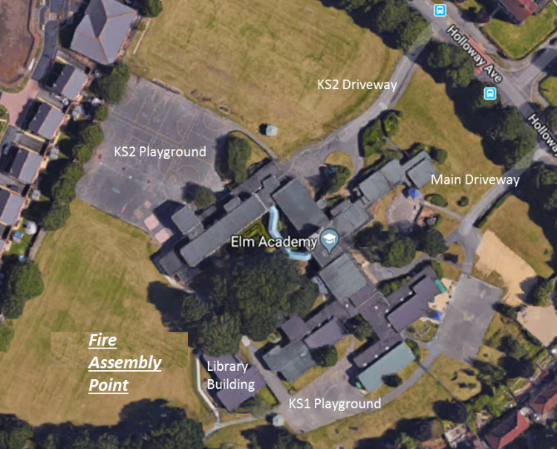

Welcome to Elm Academy
Please read the following information regarding Safeguarding and Health & Safety at the commencement of your visit.
Thank you for helping us keep all site users safe.
Safeguarding
Safeguarding is the action that is taken to promote the welfare of children and protect them from harm.
If you have concerns about safeguarding whilst on your visit to Elm Academy, please speak to the school office - 01202 574212 - who will urgently contact:
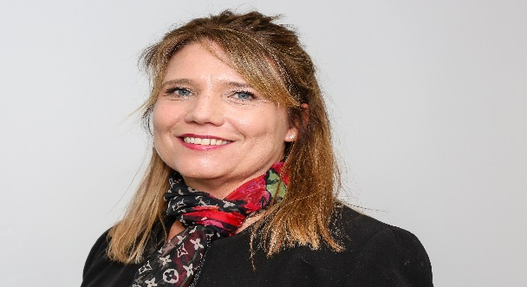
Mrs J Fish – Principal & Designated Safeguarding Lead

